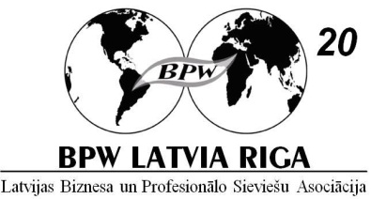
BPW Latvija – Riga 20th anniversary celebration plan
16th – 17th of August, 2013
16. 08. 2013.
10:00 – 11:00 Visit to the Latvian Parliament.
9:45 meeting place – Latvian Parliament at Jēkaba str.11 (please bring your ID)

12:00 – 17:00 Conference „BPW Latvija – Riga 20 years in Europe. Future opportunities”.
The European Union House in Riga, Aspāzija Boulevard 28 (second floor)

19:00 -23:00 Evening event on a boat ‘’Jelgava” - „Riga party on the wave”
Boat dock at Stone Bridge, 11 novembra krastmala

17. 08. 2013
10:00 – 19:00 Trip to the country side with our guests. (Cinevilla & traditional bakery)
Meeting place Akadēmijas laukums 1, next to the Latvian Academy of Sciences.
Guests staying at the NB hotel should be at the lobby 10:20.

19:00 - ... Riga City Festival evening events.

